**IDEATION PHASE**

**Problem Statements**

|  |  |
| --- | --- |
| Date | 27 June 2025 |
| Team ID | LTVIP2025TMID59820 |
| Project Name | Pattern Sense: Classifying Fabric Patterns Using Deep Learning |
| Maximum Marks | 2 Marks |

## **Customer Problem Statement Template:**

Textile manufacturers, designers, and quality inspectors struggle with misclassification of fabric patterns during production. Traditional manual inspection techniques fail to consistently and accurately identify diverse patterns across high volumes of fabrics. This project uses transfer learning to build an image-based classification system that distinguishes various fabric patterns (e.g., stripes, florals, checks) with high accuracy and speed.

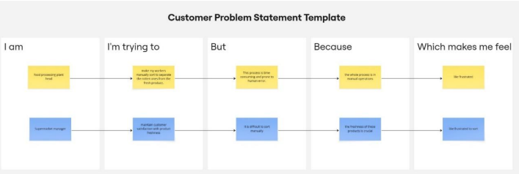

|  |  |  |  |  |  |
| --- | --- | --- | --- | --- | --- |
| **Problem Statement (PS)** | **I am (Customer)** | **I’m trying to** | **But** | **Because** | **Which makes me feel** |
| PS-1 | Textile production manager | |  | | --- | | Ensure fabrics  are correctly  classified by  pattern |  |  | | --- | |  | | |  | | --- | | Manual  inspection is  inconsistent  and  error-prone |  |  | | --- | |  | | |  | | --- | | The volume  of fabric is  too high for  manual  checking |  |  | | --- | |  | | |  | | --- | | frustrated with inefficiency |  |  | | --- | |  | |
| PS-2 | |  | | --- | | Quality  control  inspector |  |  | | --- | |  | | Maintain accuracy of pattern classification to avoid costly mistake | It's slow and depends on human judgment | Pattern details can be subtle and hard to distinguish manually | worried about quality issues |